**DAILY ONLINE ACTIVITIES SUMMARY**

|  |  |  |  |  |  |  |  |
| --- | --- | --- | --- | --- | --- | --- | --- |
| **Date:** | **01/01/2020** | | | | **Name:** | **Rohan Vashista BM** | |
| **Sem & Sec** | **6th Sem & B** | | | | **USN:** | **4AL17CS078** | |
| **Online Test Summary** | | | | | | | |
| **Subject** | | **CNSC Test2** | | | | | |
| **Max. Marks** | | **60** | | **Score** | | **48** | |
| **Certification Course Summary** | | | | | | | |
| **Course** | **Ethical Hacking** | | | | | | |
| **Certificate Provider** | | | **Alison** | **Duration** | | | **5hrs** |
| **Coding Challenges** | | | | | | | |
|  | | | | | | | |
| **Status: completed** | | | | | | | |
| **Uploaded the report in Github** | | | | **yes** | | | |
| **If yes Repository name** | | | | <https://github.com/Rohanvasista/Coding-activities> | | | |
| **Uploaded the report in slack** | | | | **yes** | | | |

**Online test details**

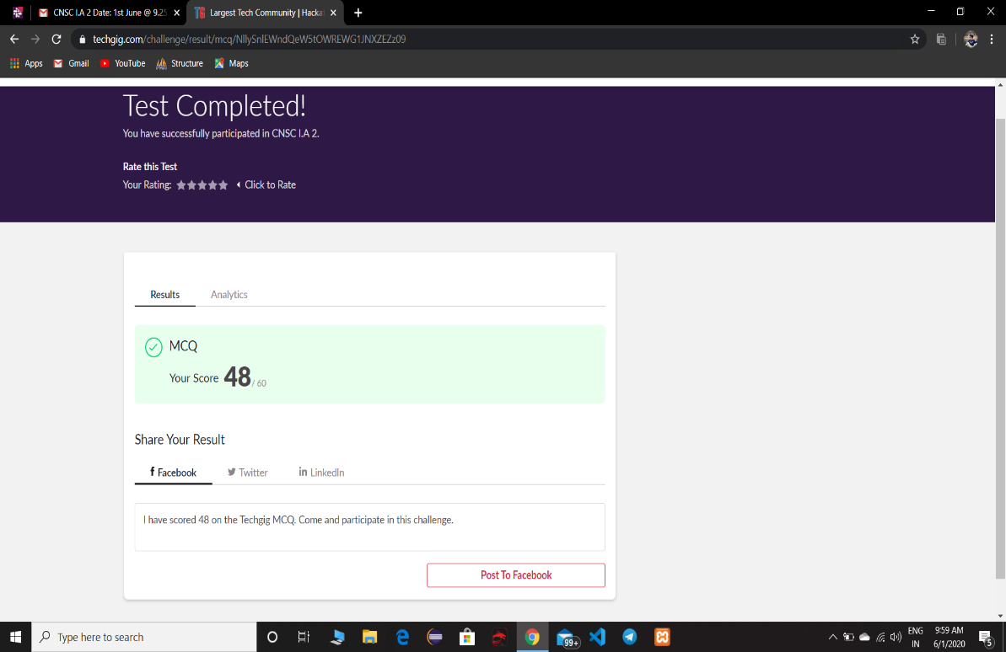

**Online Certification Details**

Completed modules

* Hacking methodology
* Scanning
* Gaining access an maintaining
* Covering topics

**CERTIFICATE OF COMPLETION**

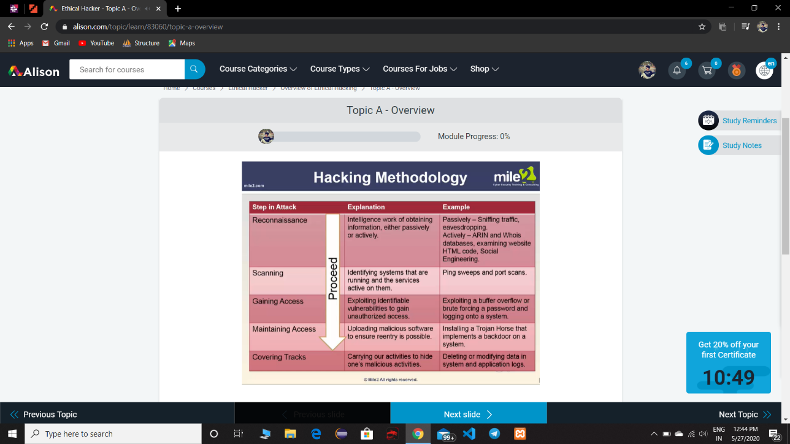

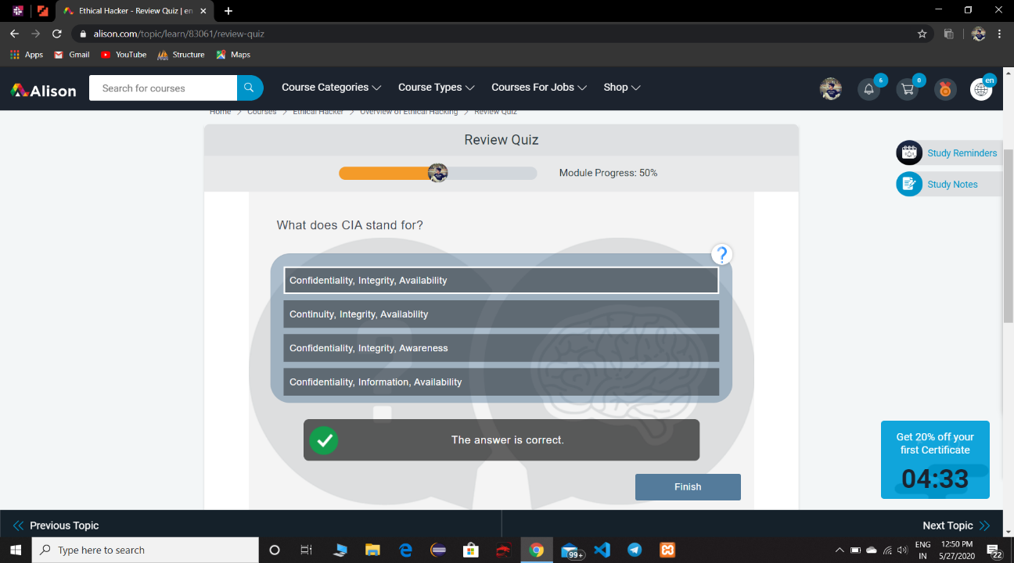

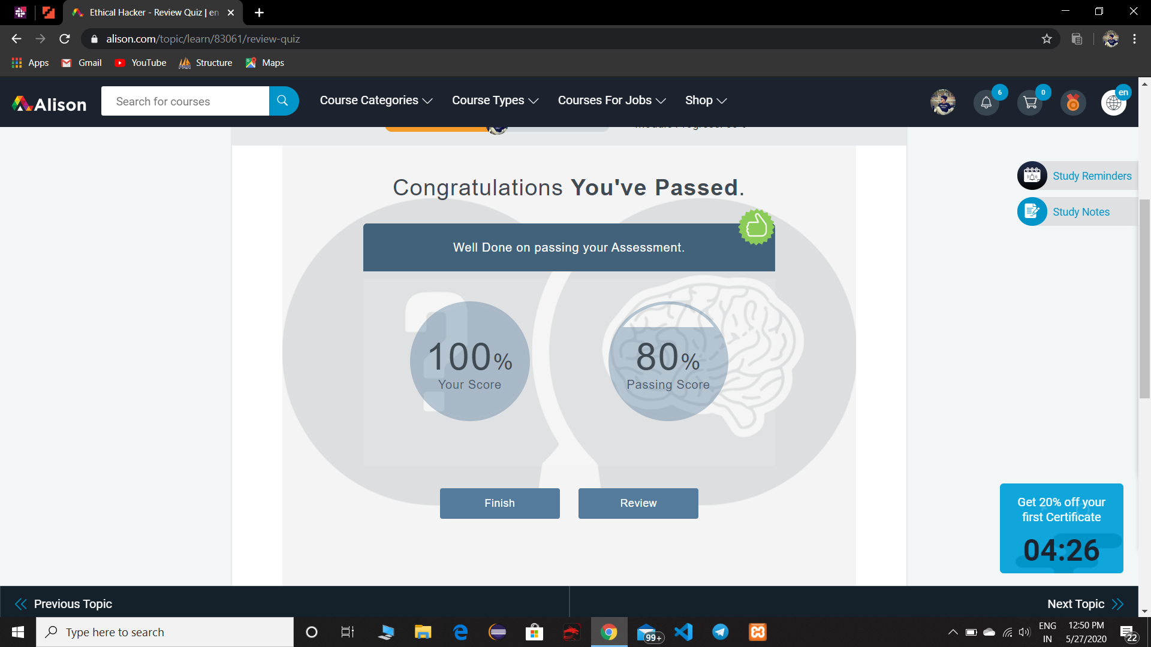

* Quiz on module 1,2.

**Coding Challenge Details**

**1.** python program to remove duplicates in list.

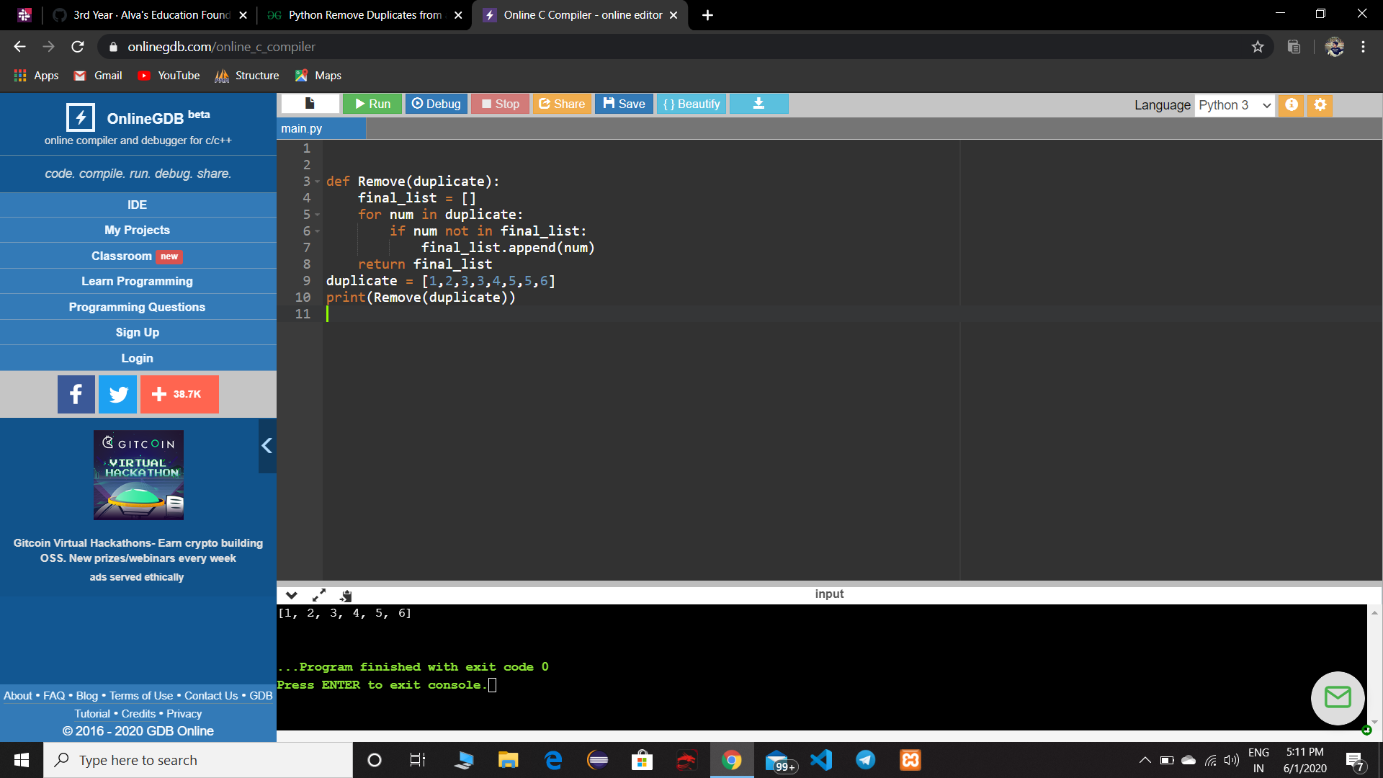

**2.** Write a Java Program to left rotate the elements of an array.

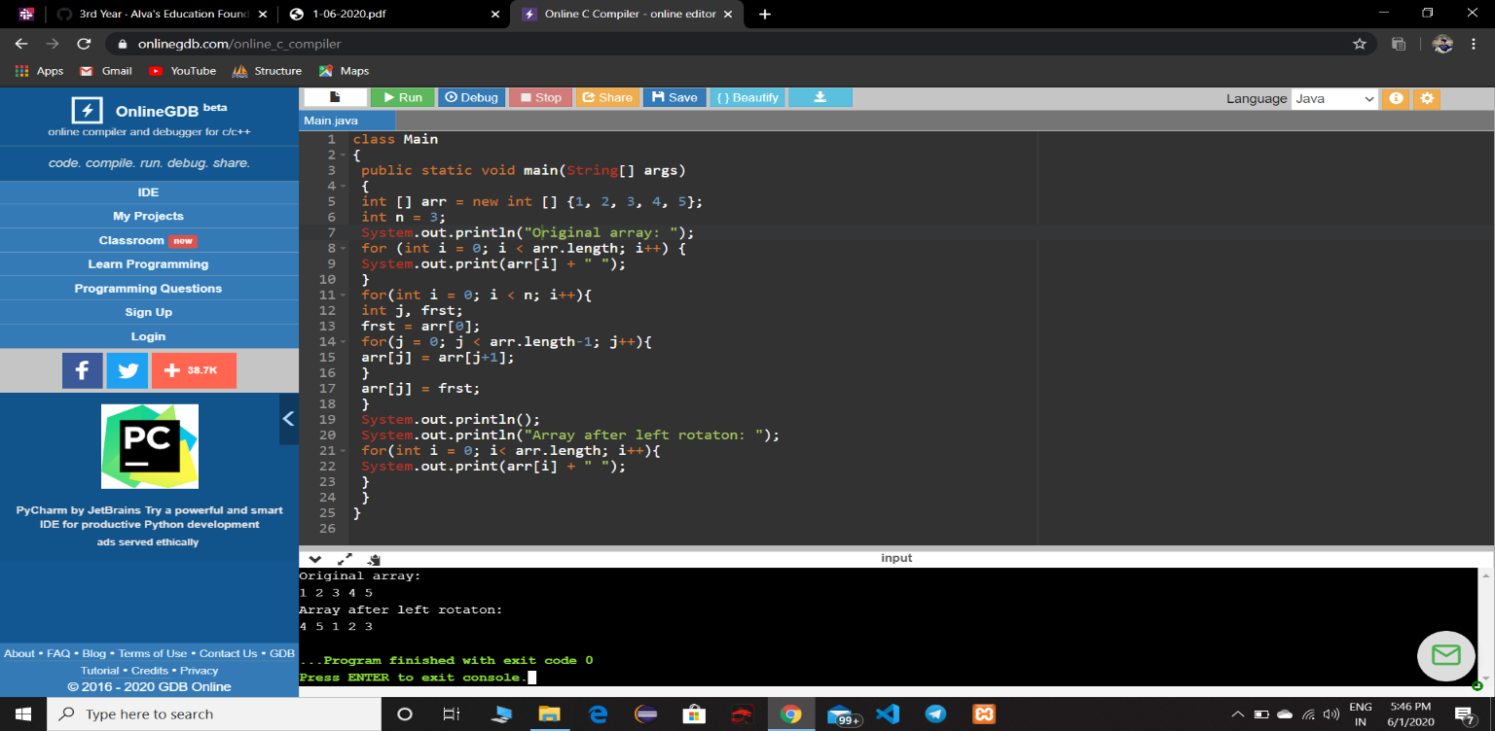

**3.** C program to find leaders of array.

